Apache JMeter
Apache JMeter may be used to test performance both on static and dynamic resources (files, Servlets, Perl scripts, Java Objects, Data Bases and Queries, FTP Servers and more). It can be used to simulate a heavy load on a server, network or object to test its strength or to analyze overall performance under different load types. You can use it to make a graphical analysis of performance or to test your server/script/object behavior under heavy concurrent load.

We Used Apache Jmeter to test the performance of few Servlets, Jsps and the Database Amazon AWS.
Procedure followed is as follows.
1) Downloaded Apache Jmeter and installed it.
2) Created 2 projects, first one is to test the Website and second one is for testing the database connection.
3) For the web testing, we created a thread group and specified the number of threads needed, how frequently those threads become active and how many times each thread becomes active. As the application was running in localhost, we specified the hostname as localhost and port 8080 and also included the path of the webpage which needs to be tested. We created 3 http requests for 3 different pages on our website.
4) For the Database, we created separate thread group and configured the database connection details and specified the number of thread and details like that as done for web configuration.
5) We then added listeners which actually records all the action when the threads are running. We created 3 Listeners for each of the thread group. A Graph listener which records all the information in form of graph, A Table view which shows in a table and a File view which saves the information in a file.
6) Then we triggered both of the thread groups and saved the images after the test is done.
Below are some of the images showing the output of various configurations.

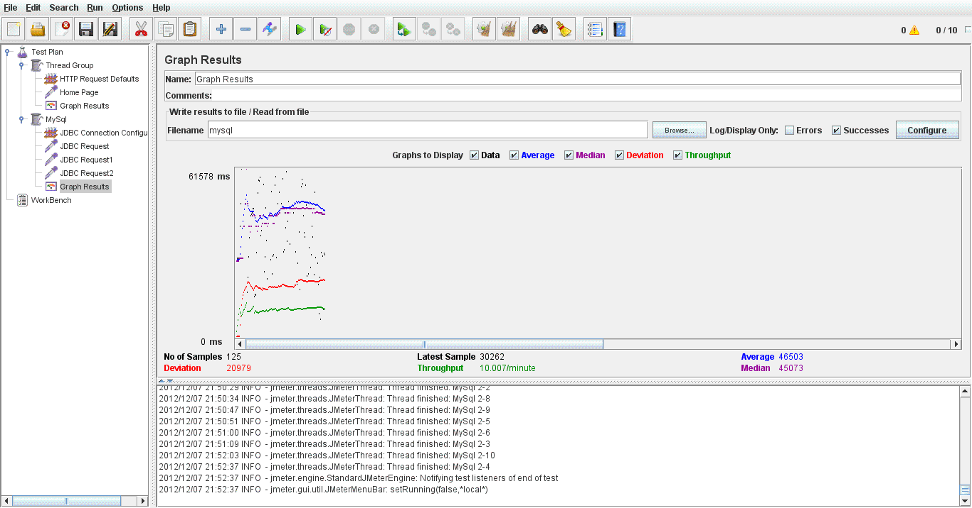
The Above image is a graph showing the performance testing done using 125 threads on the database. On the left side we can see there are 3 JDBC requests triggered by each thread. Each request is for each table in the MySQL.

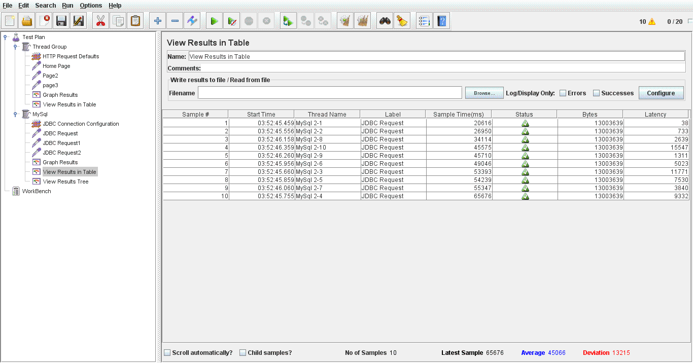
The above Image shows the result of JDBC testing in a table format. We can see that all the requests were successful as shown in the status column.

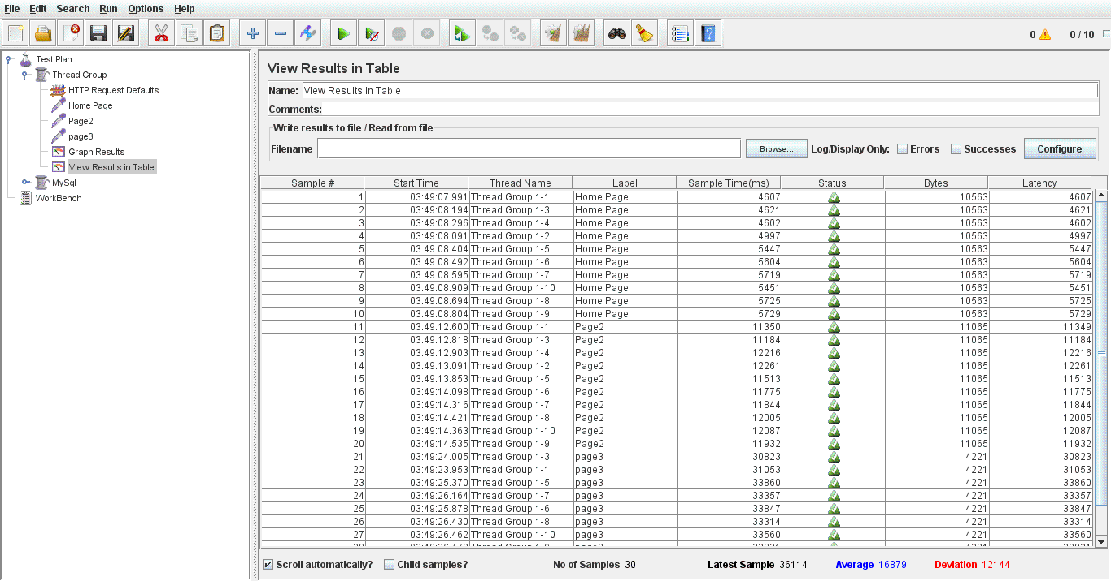

The above image specifies the results of webpage testing in a tabular format and as we can see that all the pages have returned output.

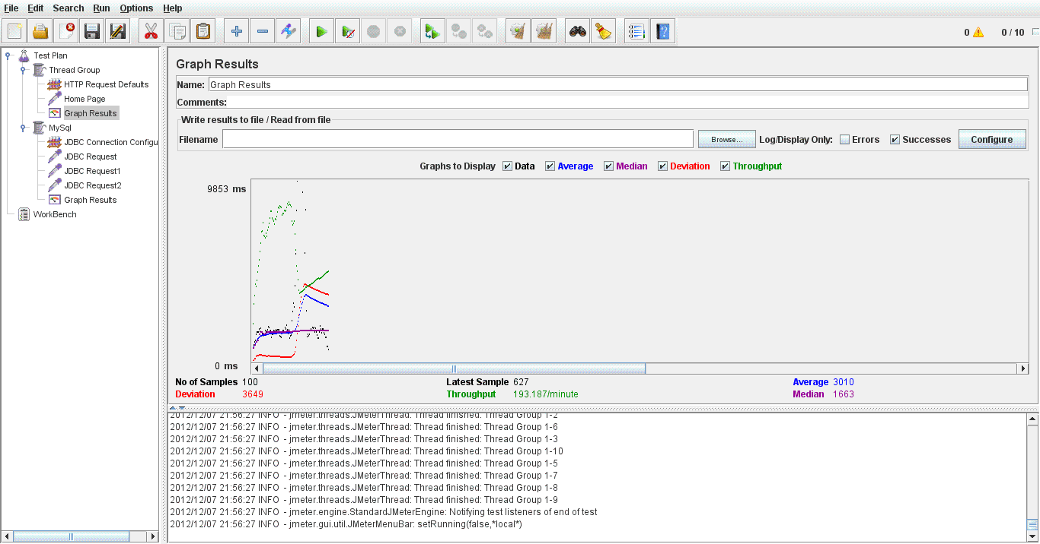
The above image is the graph output for the webpage testing using 100 threads.

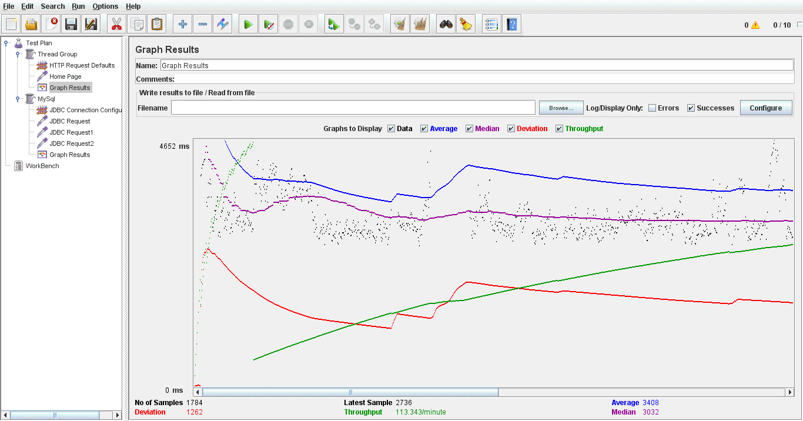
The above Image is the result of continuous performance testing of the website. It creates continuous threads and triggers the http request continuously.

